EXPERIMENT – 4

Demonstration of Hash Cracking Using John the Ripper Tool in Kali Linux

Aim
To demonstrate password hash cracking using the John the Ripper tool in Kali Linux for understanding password vulnerabilities and security analysis.

Software Requirements
- Host Operating System: Windows / Linux / macOS
- Virtualization Software: Oracle VirtualBox
- Guest Operating System: Kali Linux
- Security Tool: John the Ripper
- System Requirements:
  - RAM: Minimum 4 GB (8 GB recommended)
  - Disk Space: Minimum 30 GB
  - Processor: Intel/AMD with Virtualization support

Introduction
Password hashes are commonly used to store user credentials securely. However, weak passwords and outdated hashing techniques can be exploited using password-cracking tools.
John the Ripper is a popular open-source password auditing and cracking tool used to identify weak passwords by performing dictionary, brute-force, and hybrid attacks.
Using Kali Linux in a virtualized environment allows safe and ethical experimentation without affecting real systems.

Procedure

Step 1: Start Kali Linux Virtual Machine
- Open Oracle VirtualBox.
- Start the Kali Linux virtual machine.
- Log in using Kali credentials.

Step 2: Open Terminal
- Click on Terminal from the Kali Linux menu.
- Ensure John the Ripper is installed:
- john --version

Step 3: Prepare the Hash File
- Create a text file containing password hashes (example: hash.txt).
- Store the hash inside the file: nano hash.txt
- echo -n "password123" | md5sum
- Save and exit the file.

Step 4: Run John the Ripper
- Execute the John the Ripper command:
john --format=raw-md5 --wordlist=/usr/share/wordlists/rockyou.txt hash.txt
- The tool starts cracking the hash using default wordlists.

Step 5: View Cracked Passwords
- To display cracked passwords: john --show hash.txt

Output
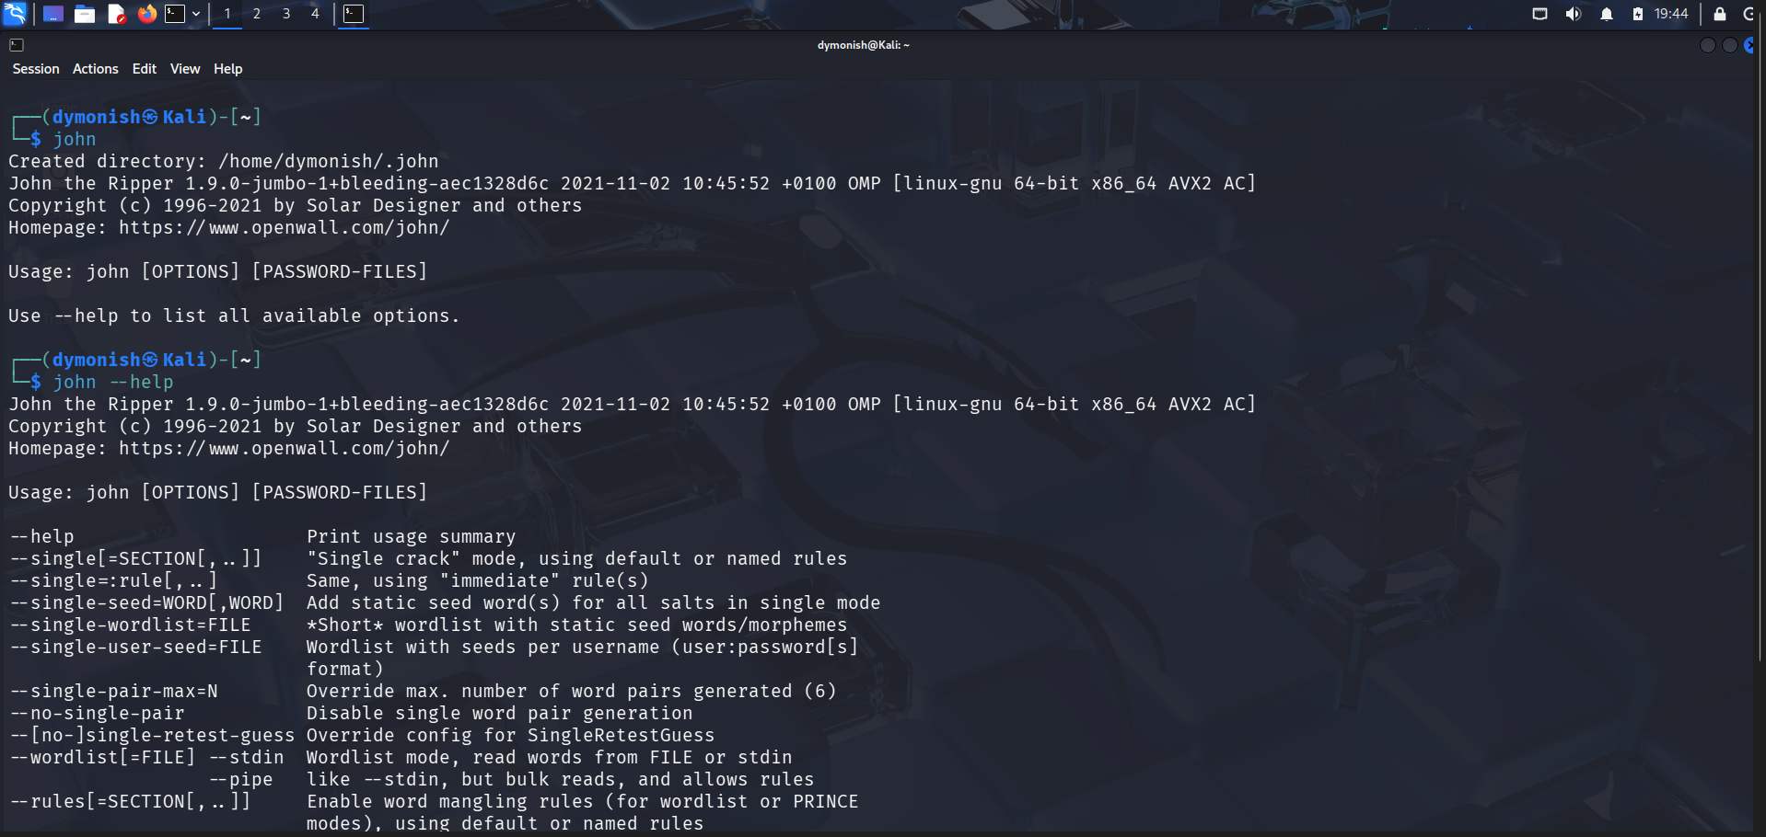
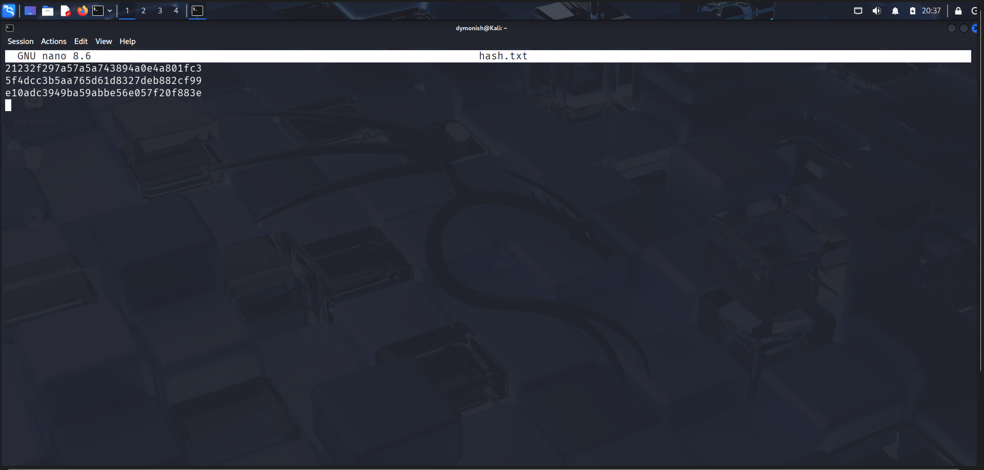
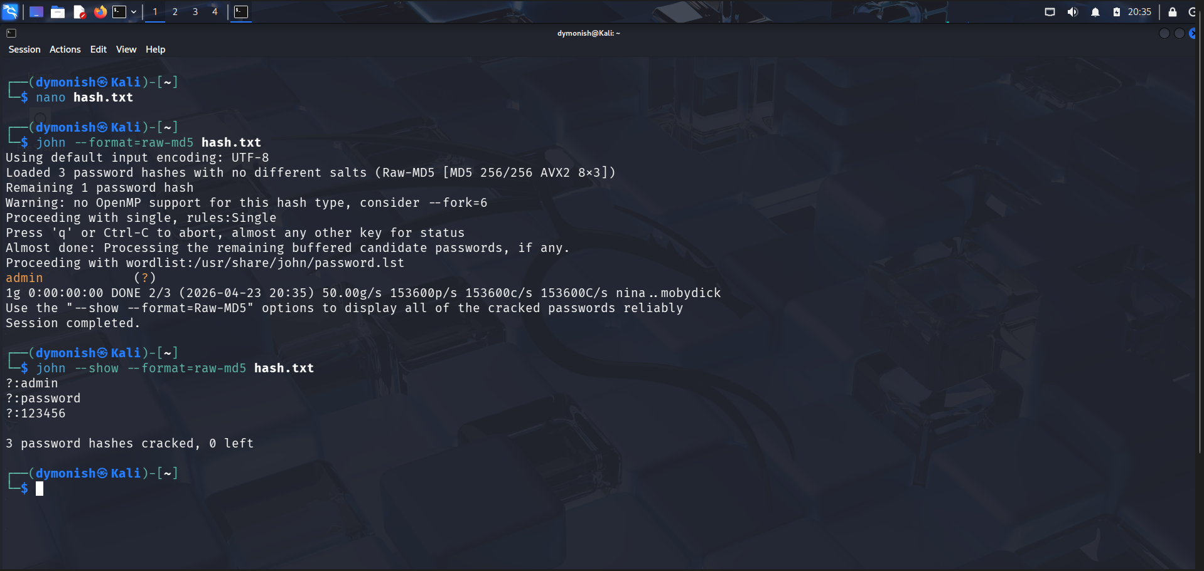

Result
Hash cracking was successfully demonstrated using the John the Ripper tool in Kali Linux.
The experiment highlights the importance of using strong passwords and secure hashing algorithms.

